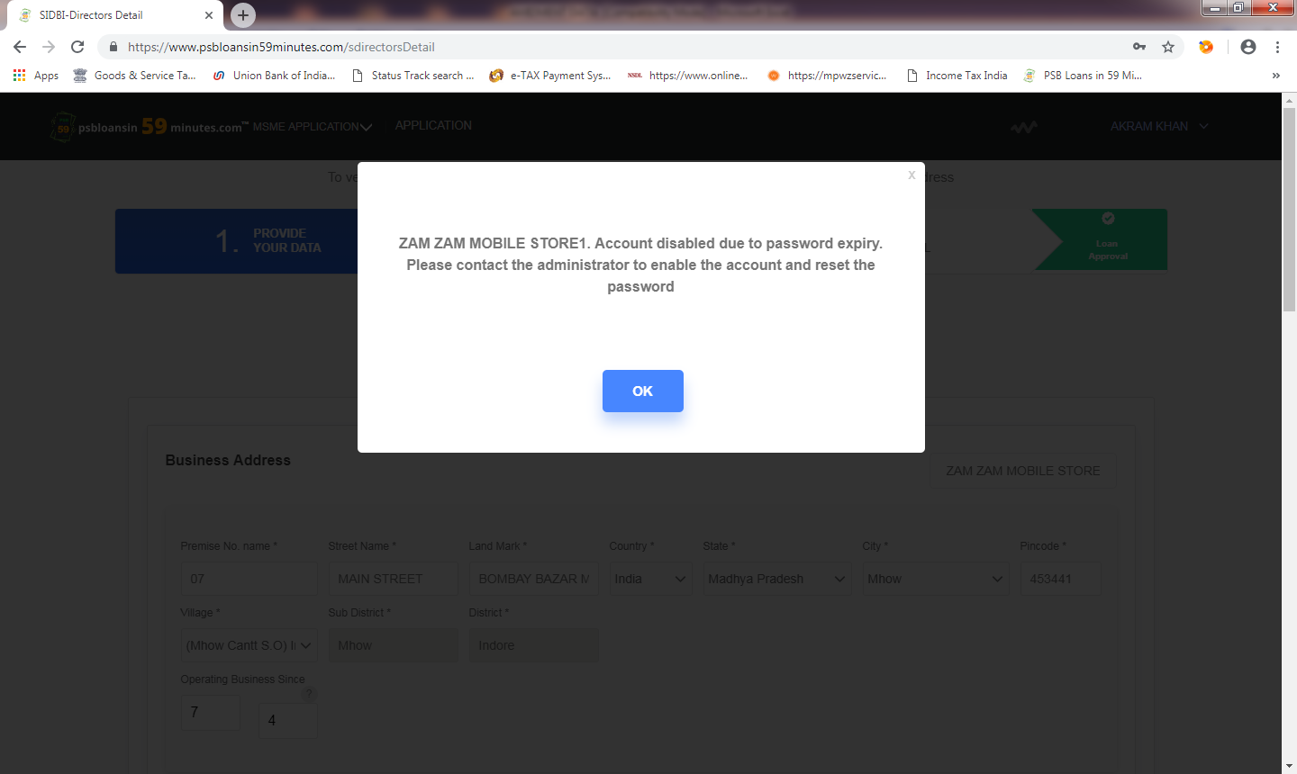

Applicant name- akram khan

Business name- zam zam mobile store

Mobile no.7000226615